

**Mathematics Specialist**

**Unit 3**

**TEST 3**

**Student name:** _______________________  **Teacher name:** _______________________

**Time allowed for this task: *45 minutes***, in class, under test conditions

Calculator-Assumed

**Materials required:**

Standard items: Pens (blue/black preferred), pencils (including coloured), sharpener, correction fluid/tape, eraser, ruler, highlighters, SCSA Formula Sheet.

Classpad Calculator and Scientific Calculator.

Special items: Drawing instruments, templates

**Marks available: *44 marks***

**Task weighting: 8%**

**Question 1 (7 marks)**

The points *A* and *B* have position vectors 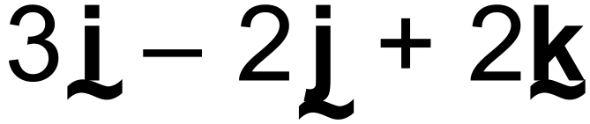 and 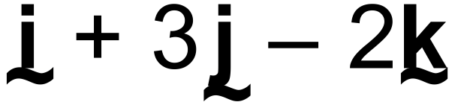 respectively.

(a) Determine a vector equation for the straight line passing through *A* and *B* (2 marks)

(b) Write your answer to (a) in its parametric equivalent and hence, or otherwise, express the Cartesian equation of the line in the form . (3 marks)

(c) Determine a unit vector parallel to the straight line in (a). (2 marks)

Question 2 (9 marks)

A plane  contains the two lines  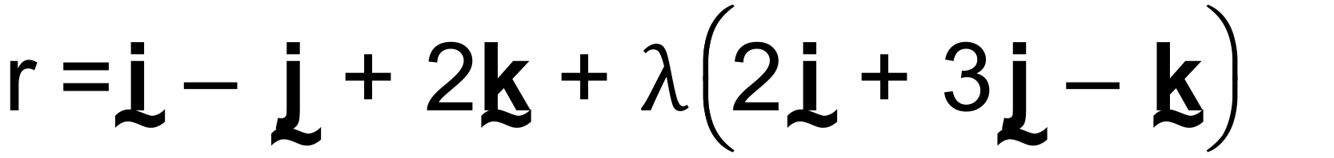 and

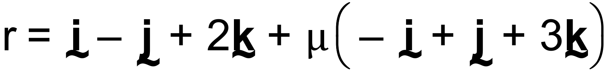

(a) Write down a vector equation of the plane . (1 mark)

(b) The point  lies in the plane . Determine the value of the constant *c*.

(3 marks)

(c) The vector  is perpendicular to the plane . Determine the values of the constants ***a***and ***b***. (3 marks)

(d) State the equation of the plane  in the form  . (2 marks)

**Question 3. (5 marks)**

(a)

(i) Find the Cartesian equation of a sphere with centre (1, -2, 3) and radius 5.

(2marks)

(ii) Hence write the vector equation of this sphere. (1mark)

(b) Find the radius and centre of a sphere with the equation: (2marks)



**Question 4 (9 marks)**

A particle P, begins from a point 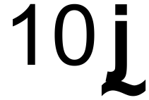 m and continues with constant velocity 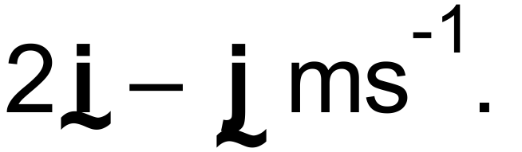

One second later another particle, starts at the point 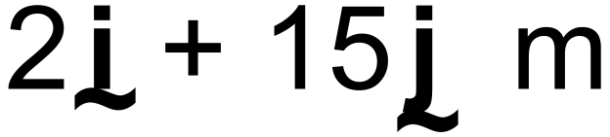 and moves with constant velocity 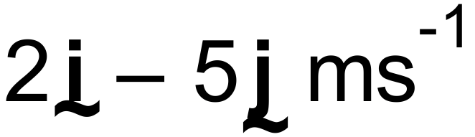 .

(a) Show that the particles collide. (5 marks)

(b) Find the Cartesian equations of their paths. (2 marks)

(c) Find the Cartesian coordinates for the point of collision. (2 marks)

**Question 5 (7 marks)**

In the diagram below,  are midpoints of the sides of the quadrilateral.

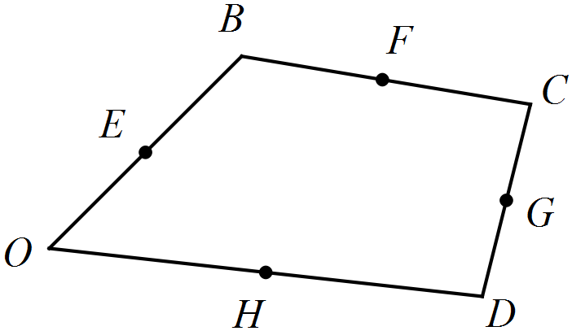

Let  .

(a) Show that 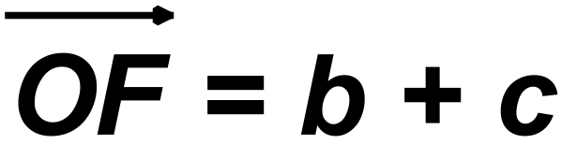 . (2 marks)

(b) Determine 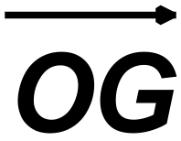 in terms of ***b, c, and d*** (2 marks)

(c) Prove that  is a parallelogram. (3 marks)

**Question 6 (7 marks)**

Use the vector product (cross product) to find the area of the triangle with vertices

**A**(-1,3,2), **B**(3,5,1) and **C**(1,6,-2)



 